data<-read.table("Data - Lab 8.txt",header=TRUE)

fix(data)

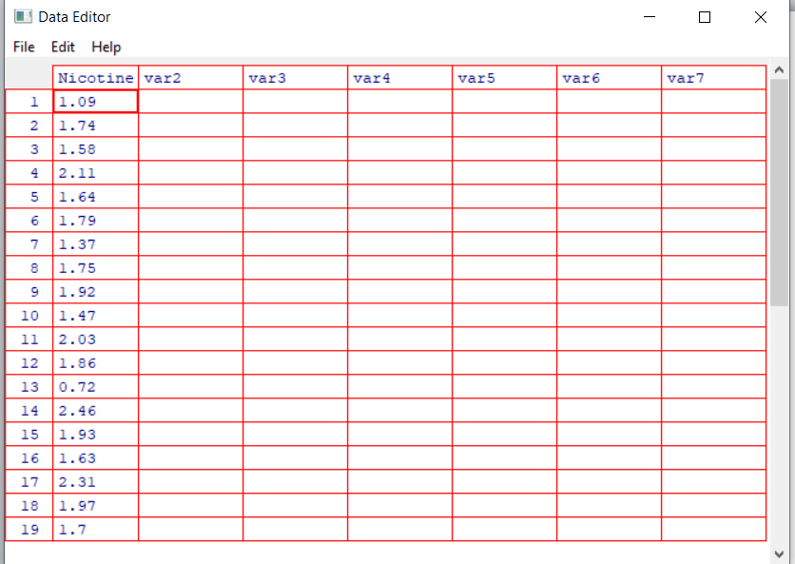

attach(data)

**Q1**

popmn<-mean(Nicotine)

popvar<-var(Nicotine)



**Q2**

#Q2

samples<-c()

n<-c()

for (i in 1:30){

s<-sample(Nicotine,5,replace=TRUE)

samples<-cbind(samples,s)

n<-c(n,paste('S',i))

}

colnames(samples)=n

s.means<-apply(samples,2,mean)

s.vars<-apply(samples,2,var)

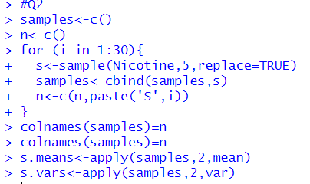

**Q3**

#Q3

samplemean<-mean(s.means)

samplevars<-var(s.means)

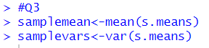

**Q4**

#Q4

popmn

samplemean

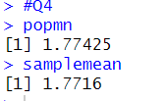

**Q5**

#Q5

truevar=popvar/5

samplevars

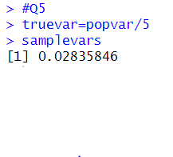

**Exercise**

**Q1**

#Q1

data<-read.table("Exercise - LaptopsWeights.txt",header=TRUE)

fix(data)

attach(data)

Weight <- as.numeric(data$Weight.kg.)

weight <- Weight

popmn <- mean(weight)

popsd <- sd(Weight)



**Q2**

samples <- c()

n <- c()

for (i in 1:25) {

s <- sample(Weight, 6, replace = TRUE)

samples <- cbind(samples, s)

n <- c(n, paste("S", i))

}

colnames(samples) <- n

s.means <- apply(samples, 2, mean)

s.vars <- apply(samples, 2, var)

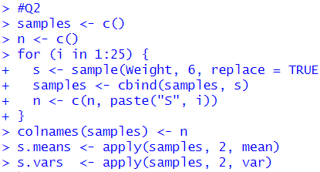

**Q3**

#Q3

mean_of_sample_means <- mean(sample_means)

sd_of_sample_means <- sd(sample_means)

